Center of Mass Prediction Using Body Accelerations and Center of Foot Pressure

ABSTRACT:
An embedded system is a special-purpose computer system designed to perform a dedicated function. Unlike a general-purpose computer, such as a personal computer, an embedded system performs one or a few pre-defined tasks, usually with very specific requirements. Embedded system comprises of both hardware and software. Embedded system is fast growing technology in various fields like industrial automation, home appliances, automobiles, aeronautics etc., embedded technology uses PC or a controller to do the specified task and the programming is done using assembly language programming or embedded C.

Modern embedded digital world will innovative the entire domain such like automobiles, industrial automation, RFID, energy meter and especially biomedical. More and more digital based medical equipment are discovered, processing of physical variable such like heart beat, blood pressure and temperature is very easy in digital circuit and you can store the data.

Project Description:
In this project of “Foot Pressure Monitor for Athletes and Patients” we measure foot pressure of Human Beings. In the transmitter side we use sensor which is connected to the footwear of the person. This sensor is interfaced using interfacing unit. The output of the interfacing unit is connected to the Atmel Microcontroller. The Controller is connected to the Battery Source. The signals from the controller are encoded using encoder and transmitted.

In the receiver side we have a decoder which decodes the signals from the transmitter. These signals are sent to the Controller. The Controller is connected to the Power Supply. With the help of PC we monitor the values of foot pressure.

Block Diagrams:

Transmitter Section:

Micro
Controller

Mems
Sensor

Battery
Source

RF
Transmitter

Signal
Conditioning Unit
Foot Pressure Sensor
Signal Encoder

Receiver Section:

RF
Receiver
Buzzer Alert
Signal
Decoder

Micro
Controller

PC
Switching Circuit
Power Supply Unit

Hardware Used :
- Foot Pressure Sensor.
- ADC.
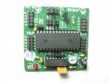
- Microcontroller.
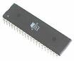
- Power Supply.
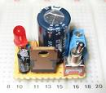
- RF Transmitter and RF Receiver Section.
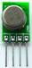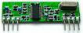
- Switching Circuit.
- Buzzer.
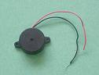

- Personal Computer.
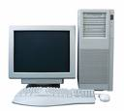
- Battery.
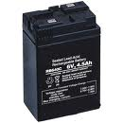

Software Used:
- Embedded C Programming.
- Keil Cross Compiler.

